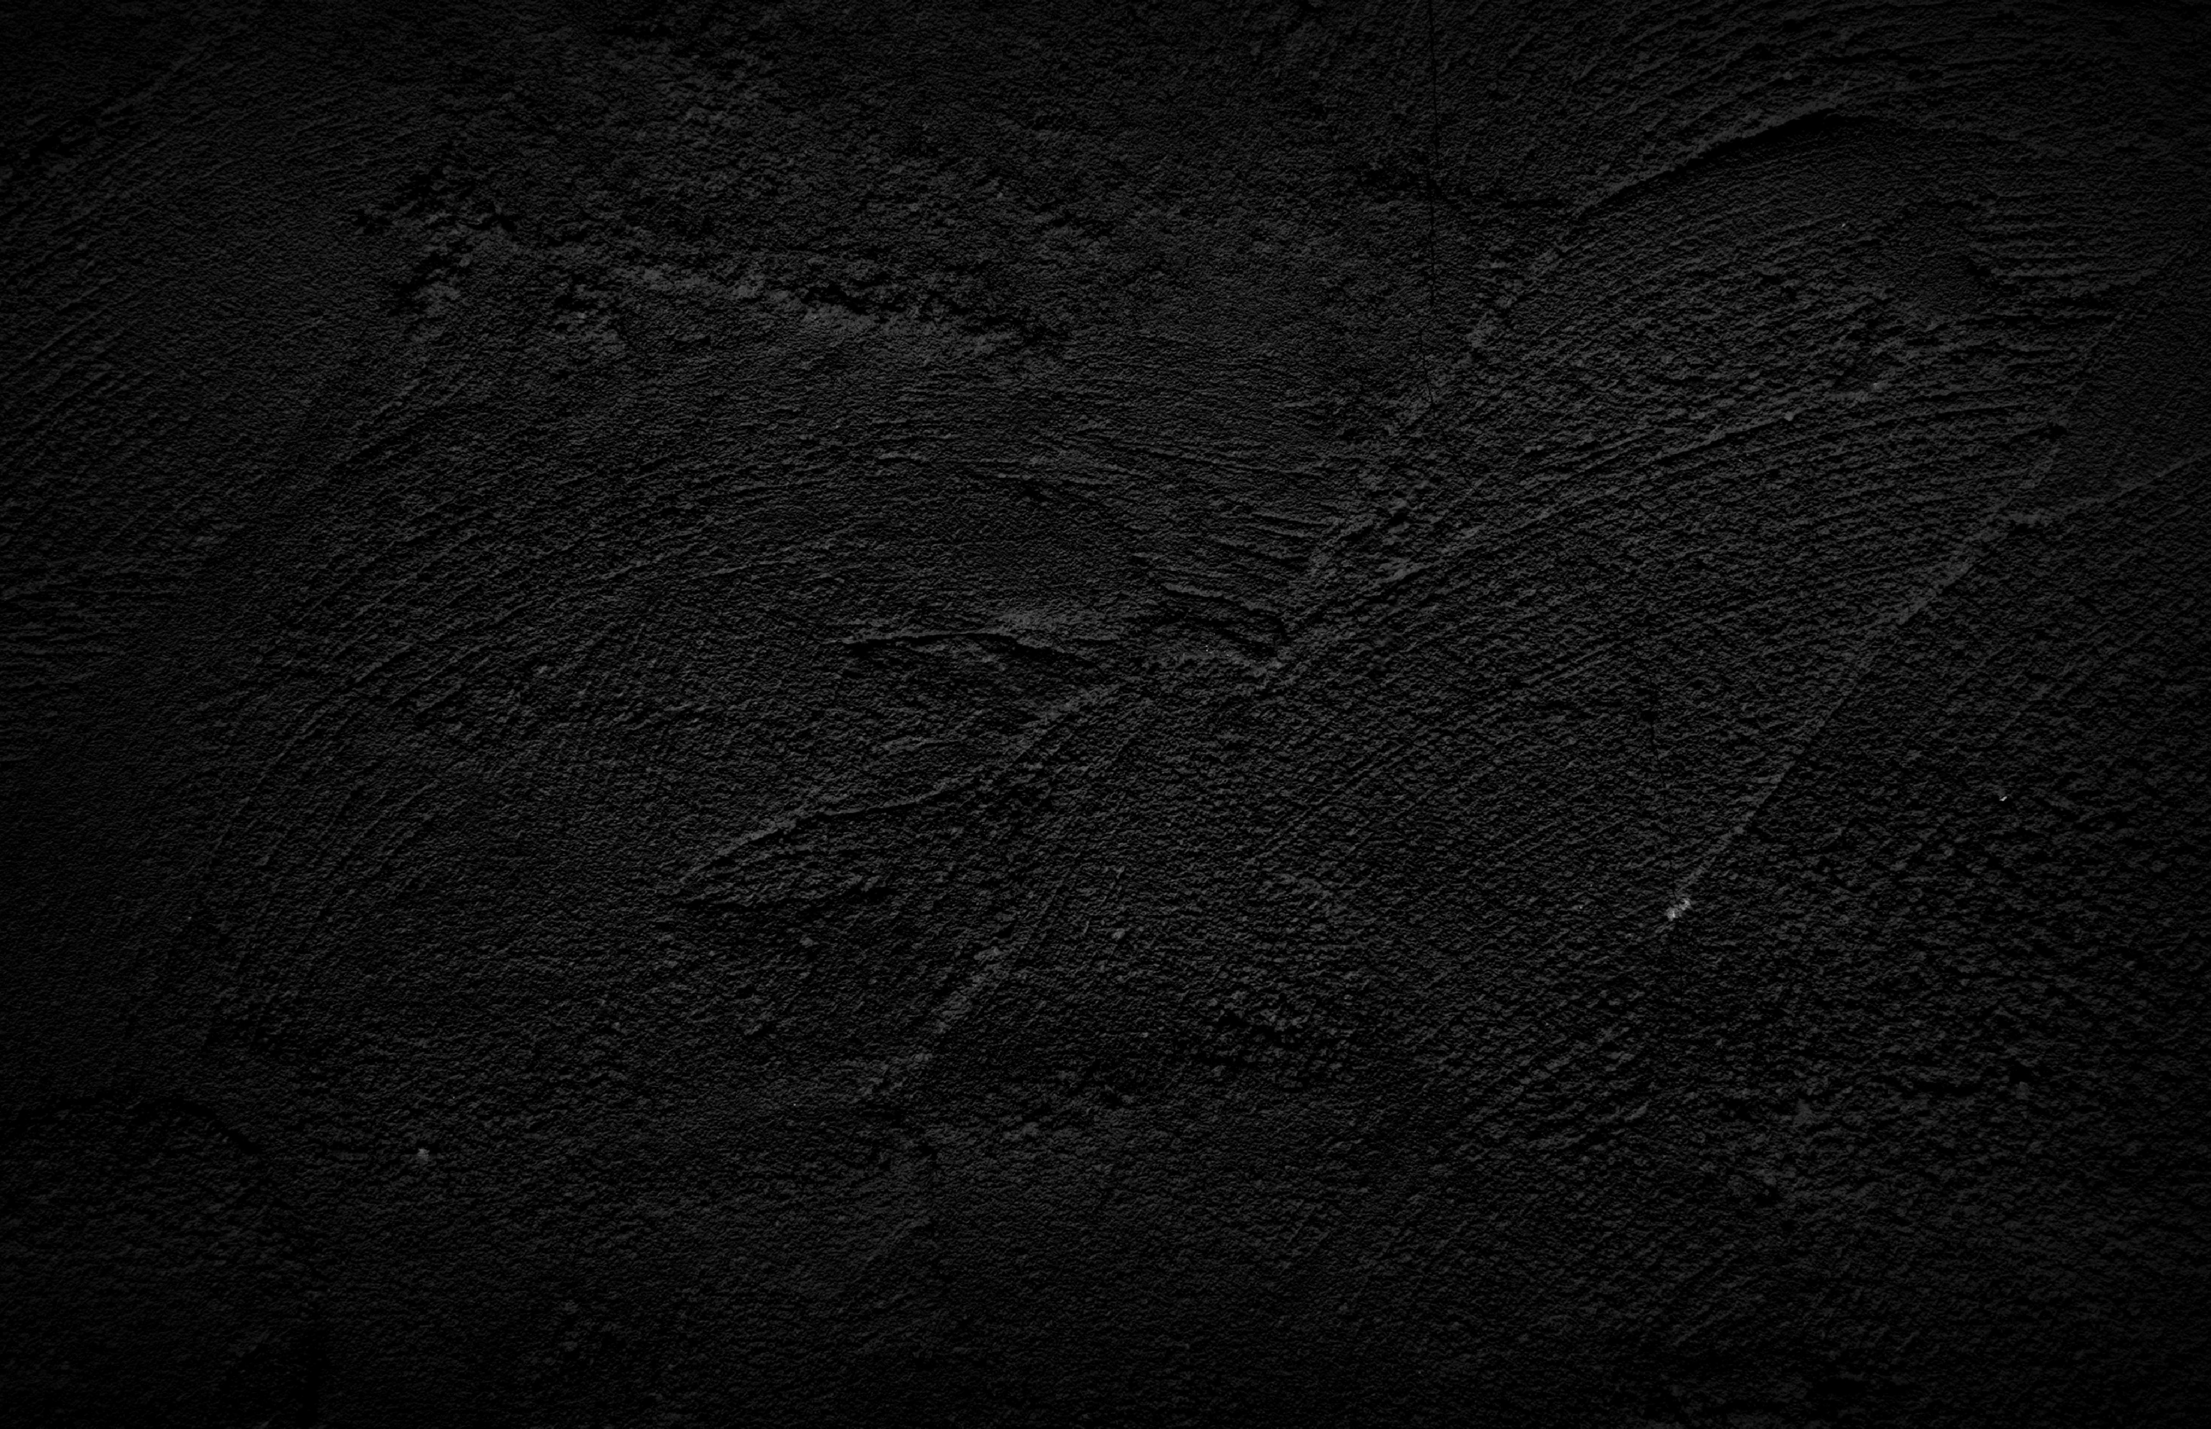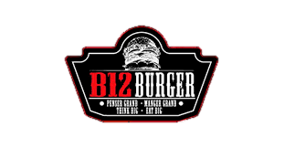

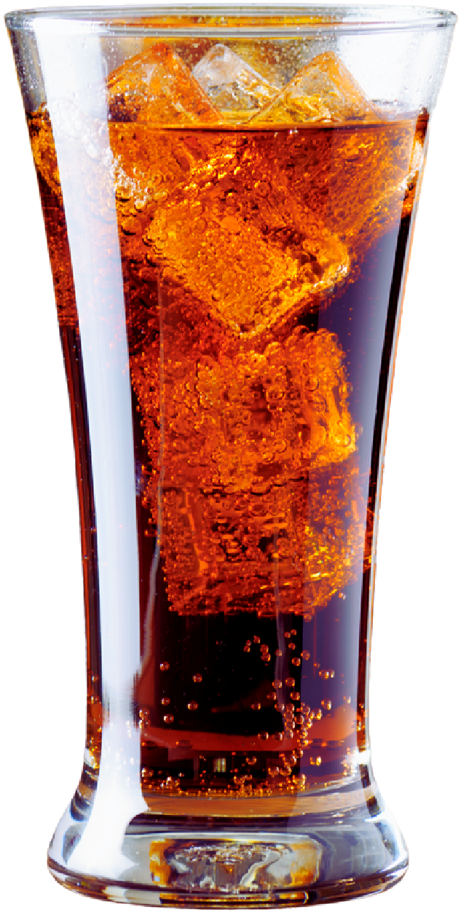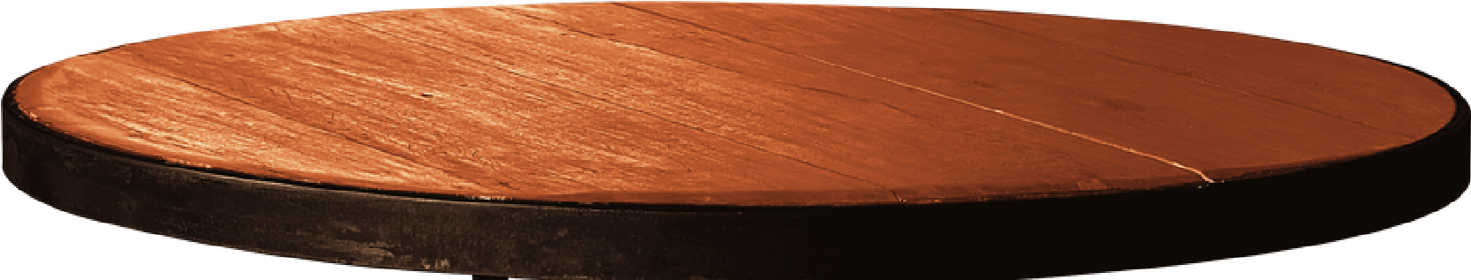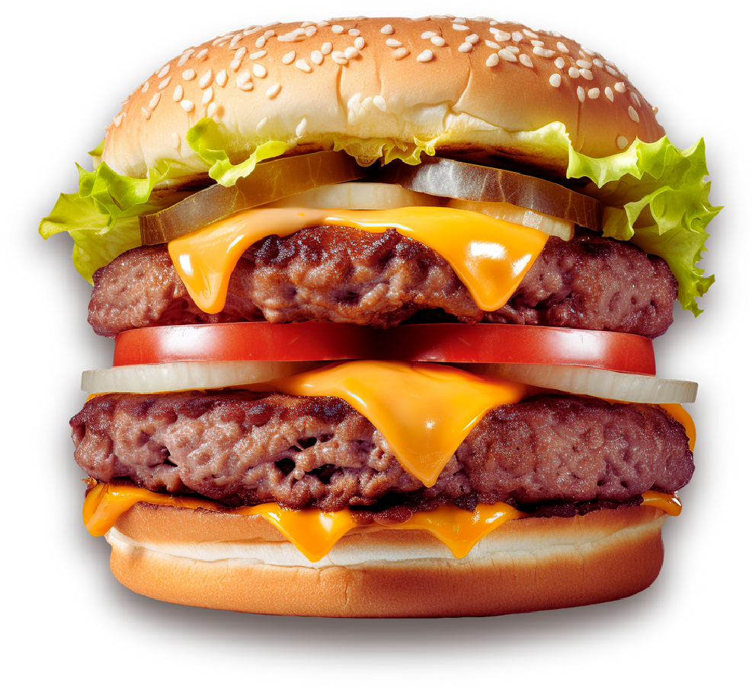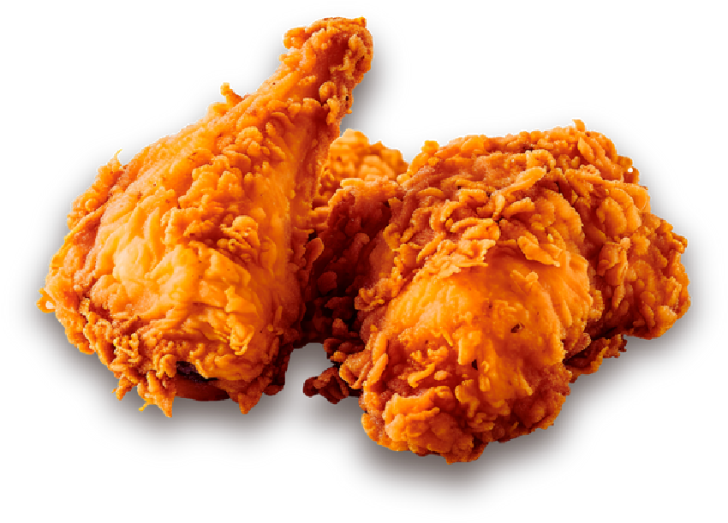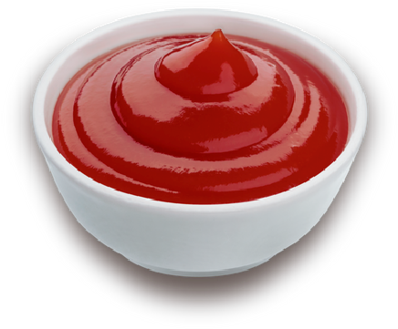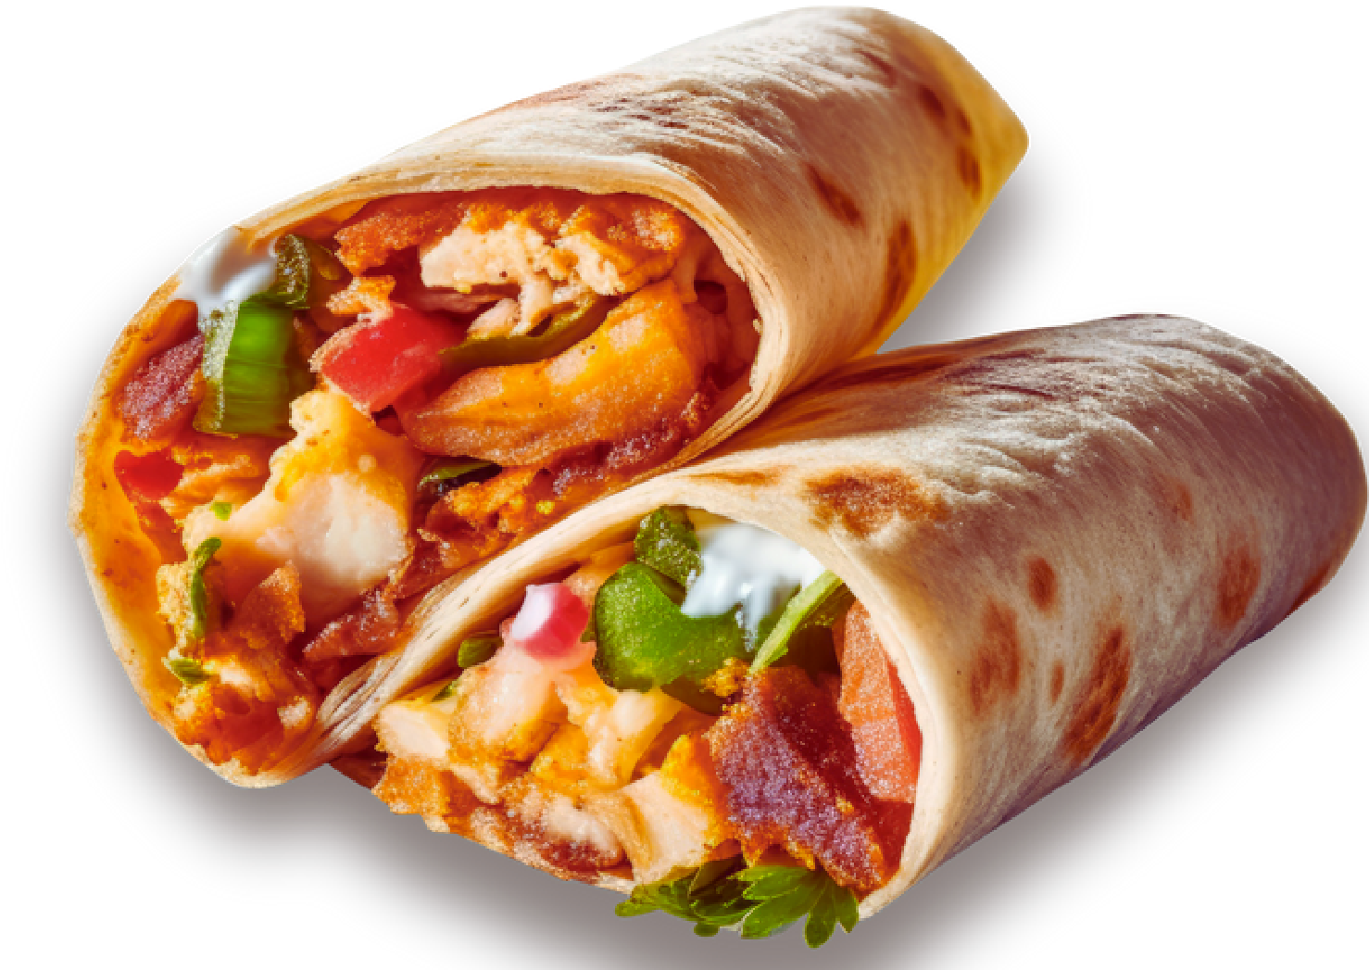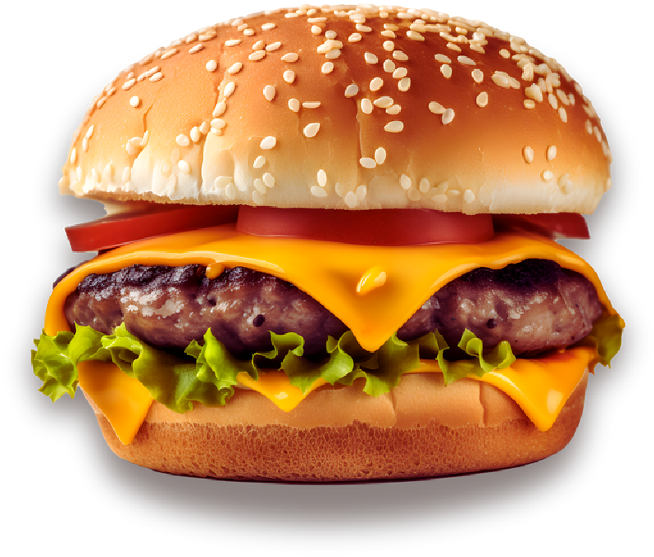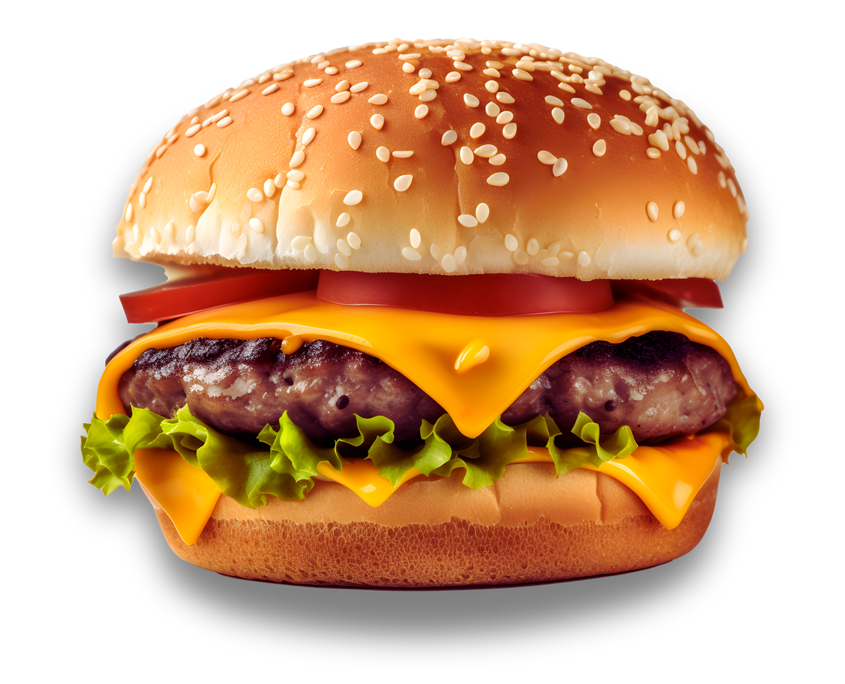

$12.50

$15.00

**1738 Bd du Curé-Labelle**

Beef Burrito

Classic burger

Chicken Burrito

Swiss Burger

Carnitas Burrito

B12 Burger

Vegetarian Burrito

Cheddar egg Burger

Breakfast Burrito

Smoked meatBurger

Fish Burrito

Double Burger

Shrimp Burrito

Turkey Burger

Chimichanga

Mushroom Burger

**+541-688-0404**

Burger

Burrito

$12.50

$16.00

$13.00

$14.00

$13.00

$13.00

$13.50

$13.50

$13.00

$15.50

$12.50

$12.50

$12.00

$13.00

